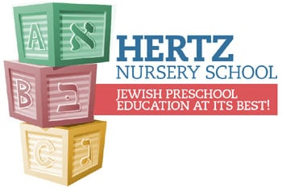
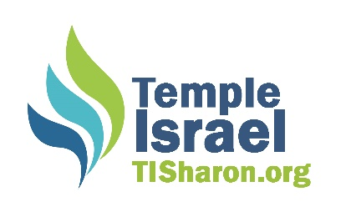
HERTZ NURSERY SCHOOL 2022-2023 REGISTRATION

Child’s Name: _____________________________ Date of Birth: ________________
Child’s Hebrew Name (if applicable): ________________________________________
Address: ______________________________________________________________
Parent Names: _______________________ _______________________________
Parent Cell Phones: ____________________ _______________________________
Parent Emails: ________________________ ______________________________

I am registering for: ___ Young Toddler Program (15-20 Months)
___ Older Toddler Program (21 Months and up)
___ 3 year old Program
___ 4 year old Program
___ Transitional Kindergarten Program

Program Options:

Morning Core Program (9:00 am-1:00 pm):

___ 2 mornings (Tuesday, Thursday- Toddler and 3 year old classes only)
___ 3 mornings (Monday, Wednesday, Friday)
___ 4 mornings (Monday, Tuesday, Wednesday, Friday)
___ 5 mornings (Monday-Friday)
___ Transitional Kindergarten (Monday-Friday mornings and Wednesday Afternoon)

Additional Options:
Early Drop Off (7:30 am-8:55 am) ___M ___T ___W ___Th ___F
Early Drop Off (8:00 am-8:55 am) ___M ___T ___W ___Th ___F

Afternoon Programs:
Enrichment:
Monday-Thursday (1:00-3:00 pm) ___M ___T ___W ___Th ___Friday (1:00-2:30 pm)

Stay and Play:
Mon.-Thurs. (3:00-4:30 PM) __M __T__W __Th __Fri. (2:30-4:00 pm)
Mon.-Thurs. (3:00-6:00 pm) __M __T__W__Th __Friday (2:30-4:00 pm)

Registration Fee: $500
-Checks made payable to Temple Israel/Memo Line Hertz Nursery Registration
-Registration fee is non-refundable
-Free Temple Israel membership for first year new families! Interested: YES___ NO___

